Recommendation Systems (RS)

Definition
- RS aim to predict users’ preferences for a certain item, and provide personalized services
- Recommendations can be personalized (tailored to the user) or non-personalized (like “Top 10 lists”).
- Collect user preferences via Data and Knowledge Sources: items (attributes, IDs, ontologies), users (demographics, behavior, trust networks), transactions (explicit ratings or implicit interactions, including multi-step conversational logs).
- Analyze data to discern user preferences, assist users in efficiently sifting through information, direct users to content most relevant and valuable for their interests
- Help cope with information overload and reduce “choice paralysis” on e-Business, social networks (YouTube, Facebook), cloud-based, mobile platforms,
- Especially useful for users lacking sufficient knowledge or experience to evaluate all options, provide benefits to businesses.
- Service provider motivations: boost sales, diversify offerings, enhance satisfaction, increase loyalty, optimize inventory/marketing.
- User motivations: discover items, find all relevant options, get context-aware highlights, receive sequences/bundles, support browsing, identify credible recommenders, refine profile, express opinions, contribute or influence.

Architecture Examples
- Netflix: three-tier architecture [Amatriain],
- YouTube: recommendation platform, pipeline with ranking, deep learning models [Medium],
- Eugene Yan: 2x2 blueprint,
- Nvidia: 4-stage blueprint,
- Tourism RS: multi-layer recommendation [ResearchGate],
- Smart City Fitness RS: exercise routes, context-aware [Computer.org],
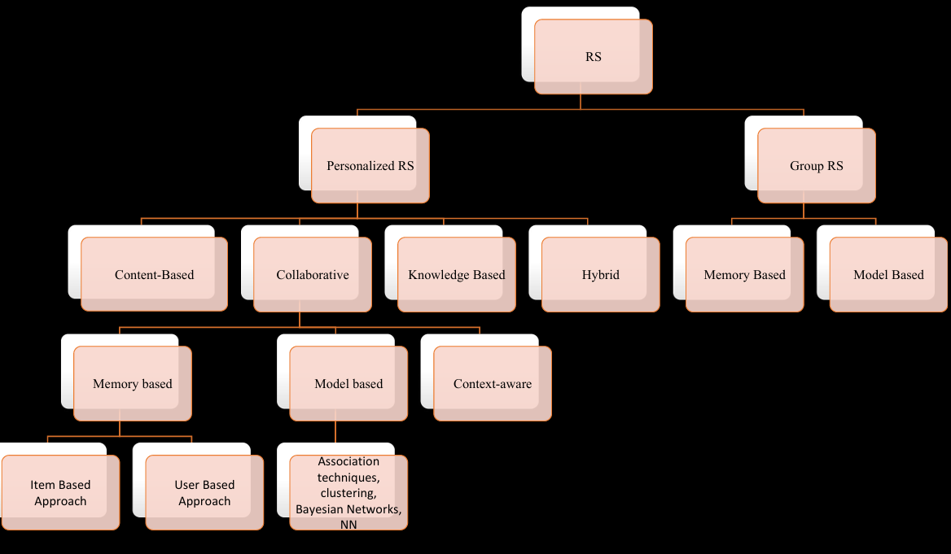
- LLM-based Personalized Health Recommendations [Preprints.org].
Challenges in RS – Commercial Perspective
- Robustness (stability): ability to maintain accurate and effective recommendations with varying/unexpected data,
- Fairness (fair treatment): provide unbiased and equitable recommendations regardless of demographics,
- Data Bias (distortion): systematic deviations in data causing unfair/inaccurate recommendations.
Further Challenges:
- Cold Start → New users/items, little data
- Data Sparsity → Mostly empty user–item matrix
- Scalability → Handling large datasets efficiently
- Overspecialization → Lack of diversity in results
- Bias & Fairness → Skewed or unfair recommendations
- Privacy → Sensitive data concerns

Types of Recommendation Systems

1. Personalized RS
- Content-Based Filtering (CB) is a type of recommender system that recommends items similar to those a user has liked in the past. It treats recommendations as a user-specific classification problem, learning a classifier based on an item's features. It relies on item features, a user preference model, and a user's interaction history. Determines and differentiates the main common attributes of a user's favorite items by analyzing the descriptions of those items. A common approach is the use of Heterogeneous Information Networks (HINs), which integrate multiple types of side information (multiple item types, related links) in a parallel manner, adding richer semantics. The recommendation process can use either clustering or ranking methods, utilizing similarity metrics such as Kendall-Tau, Spearman, and Pearson. Item representation can be based on structured data (attributes), textual data (descriptions), and semantic analysis (using lexicons and ontologies like WordNet). A key challenge with content-based filtering is overspecialization, which can lead to a lack of diversity in recommendations.
- Collaborative Filtering (CF): Recommends items liked by similar users, uses user profiles created from historical interactions (browsing, purchases, listened songs). Collaborative Filtering-based (CF) methods are primarily used in big data processing platforms due to their parallelization characteristics.
  - Memory-based CF: This technique makes recommendations based on the similarity between users or items. The algorithm involves two steps: first, calculating similarity between users or items using a nearest neighbor-based method, and second, generating recommendations based on the sorted similarity values. Memory-based CF can handle large amounts of data and capture user behavior patterns for personalized recommendations, but it faces challenges with sparse interaction matrices and computational difficulties in large user or item spaces. Solutions include embedding techniques (prefs2vec, graph-based embeddings) to reduce computational complexity and learn user/item representations. Similarity metrics include (based on co-rated items): Pearson Correlation Coefficient (PCC), Cosine similarity, Mean Squared Difference (MSD), Proximity Impact Popularity (PIP), Jaccard Similarity, Proximity Significance Singularity (PSS).
  - Model-based CF: predicts user preferences based on relationships between them and items, uses neural networks (Convolutional Neural Network (CNN), Long Short-Term Memory (LSTM), Recurrent Neural Network (RNN), and Auto-Encoder), latent feature learning (Multi-Layer Perceptron (MLP) in Neural Collaborative Filtering (NCF), and Neural Network Matrix Factorization (NNMF)). The basic framework involves mapping user and item representations, and reviewing text data, into a continuous vector space via a neural network, then optimizing parameters to minimize prediction error and feeding the predicted rating into a factorization-based method.
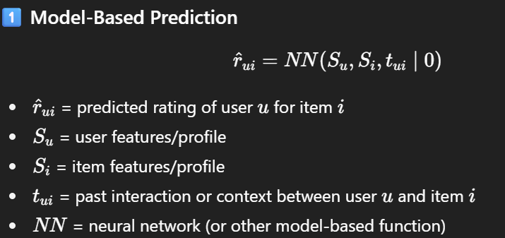

  - Context-Aware CF: Enhances recommendation by incorporating contextual information (time, location, mood, weather, day type, language, social status), sources include smart device sensors (accelerometers, gyroscopes, magnetometers, GPS, biometric). The complexity of context information (up to 600 variables from smart devices) makes it a challenging task to incorporate fully. A direct approach to reduce complexity is using latent context embedding with an Autoencoder
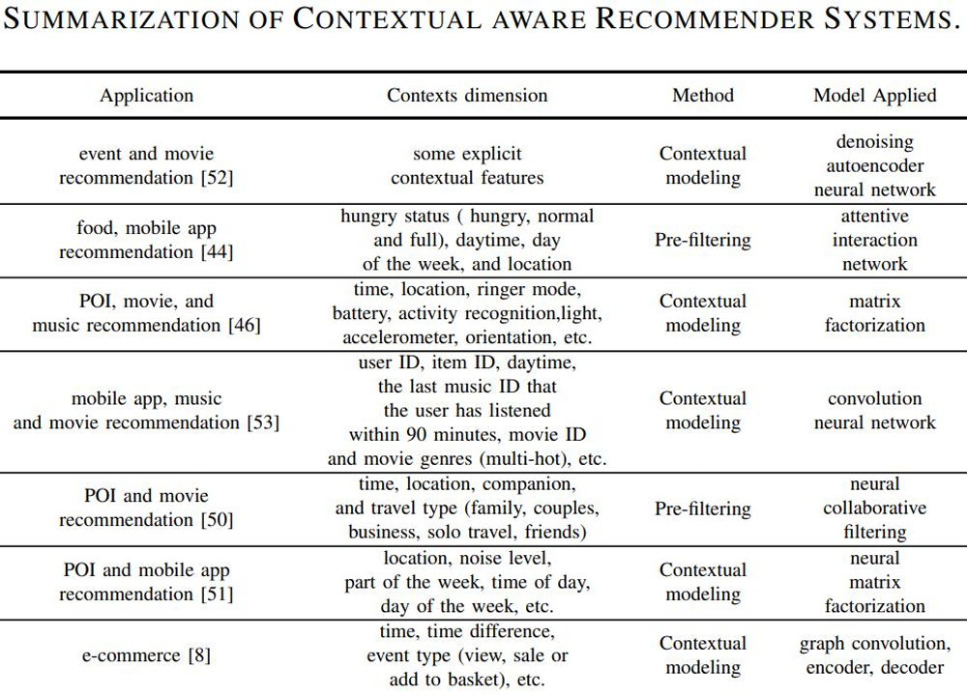

2. Knowledge-Based RS
- Case-based or constraint-based; recommendations based on user requirements and explicit domain knowledge. Operates without user-item interaction history, suitable for complex domains (cars, luxury items), uses domain knowledge (user, item, interactions), methods: Knowledge-aware Coupled Graph Neural Network (KCGN), Knowledge Graph-based Intent Network (KGIN), Knowledge-Enhanced Hierarchical Graph Transformer (KHGT), Safe Medicine Recommendation (SMR) in medical sector. Involves an Expert System with a Knowledge Base (knowledge from an Expert) and a Rules Engine, which interacts with a Non-expert User via a User Interface for sample input and advice

3. Hybrid RS
- Combines multiple recommendation approaches, integrates multi-source information (context, content), deep learning improves fusion, For example, some models blend user-item interactions and contextual features for recommendations. Goal; To achieve real-time, accurate recommendations by integrating various data sources.
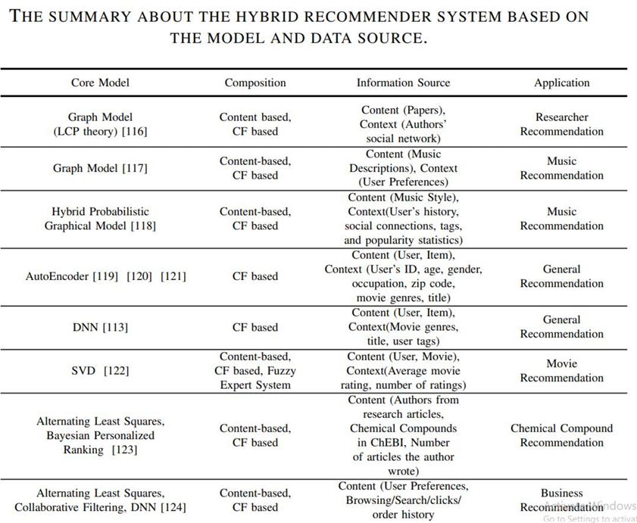

4.

Group RS
- Provide recommendations to a group of users with similar preferences rather than individualized recommendations, can be memory-based or model-based. Applications: travel, dining, collaborative platforms. Takes individual Preferences (Preference User 1, Preference User 2, etc.) and Item Candidates along with Items Correlations to produce Group Recommendation via methods like Merging, Individual Recommendation, Preference Aggregation, or Group Models

Performance Measures of RS

1. Rating-Based Indicators (RBI)
- Evaluates the quality of the prediction rating score by calculating the gap between implicit/explicit labels, popular metrics:
  - Root Mean Squared Error (RMSE): sensitive to outliers, lower is better,
  - Mean Absolute Error (MAE): lower is better, sensitive to outliers.
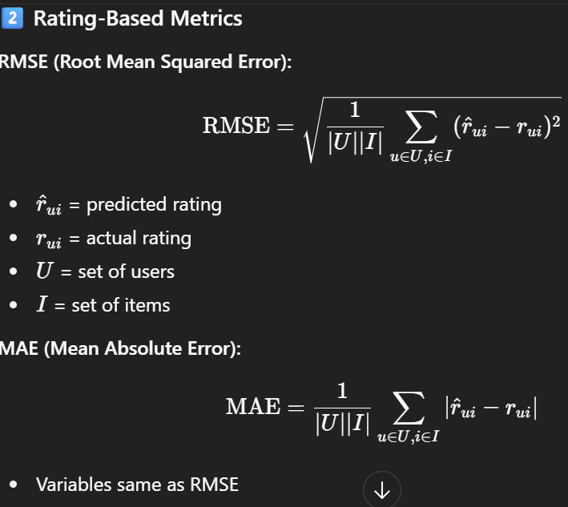

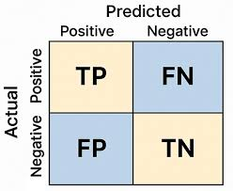
2. Item-Based Indicators (IBI)
- Evaluate quality of recommended item sets, used when there is no ranking information, metrics derived from confusion matrix:
  - TP: recommended and used,
  - FP: recommended but not used,
  - FN: not recommended but used,
  - TN: not recommended and not used.
- Derived metrics: Precision, Recall, F-Measure, top-k Precision@k, Recall@k, mean average precision (MAP@k), mean average recall (MAR@k).



Ranking Indicators

Since most recommendations are ordered lists, metrics like Precision and Recall are less useful because they don't consider the order.

Top-k Precision and Recall: These metrics consider only a subset of the ordered list, from the first to the k-th item.

Mean Average Precision (MAP@K): Measures the average precision of recommendations up to position K across all users. It rewards systems that place relevant items higher in the list. It's calculated by averaging the precisions at positions where relevant items appear for each user, then taking the mean of those averages across all users.

Limitations: Highly sensitive to the choice of K, insensitive to the absolute number of relevant items, assumes binary relevance (graded preferences must be thresholded), is a poor fit for non-ranked scenarios, and can be affected by query difficulty and ignores non-relevant items explicitly

Mean Average Recall (MAR@K): Measures the average recall up to position K across all users. It assesses how well the system retrieves all relevant items within the top K recommendations. It's calculated by averaging the recalls at positions where relevant items appear for each user, then taking the mean of those averages across all users.

Limitations: Less sensitive to ranking order, meaning items lower in the list contribute equally. It also has the same sensitivity to the choice of K as MAP, assumes binary relevance, and potential skew with few relevant items

Normalized Discounted Cumulative Gain (NDCG): A more widely used metric that addresses the drawbacks of MAP@k and MAR@k by considering the ranking and improving evaluation quality with fine-grained numerical ratings. Puts highly relevant items at the top. It evaluates how well a ranked list places more relevant items higher, using a "discount" to reduce credit for items at lower ranks. NDCG supports graded relevance and is normalized to a value between 0 and 1. A disadvantage is that it can't handle incomplete ratings, requiring missing values to be filled (e.g., with mean/median) before calculation.
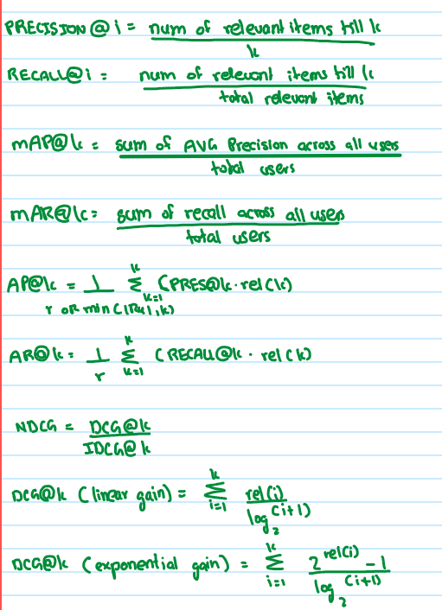
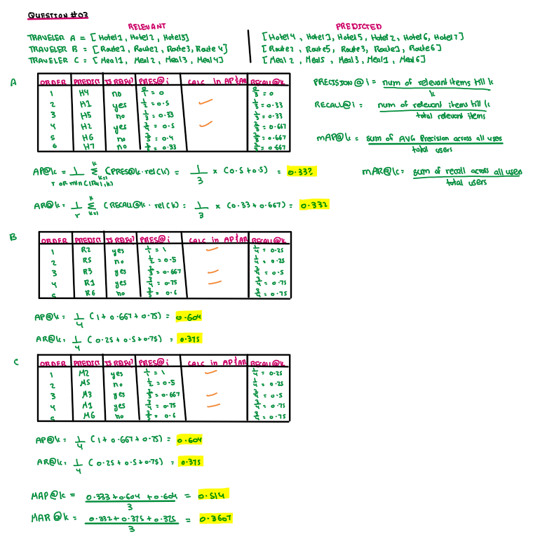
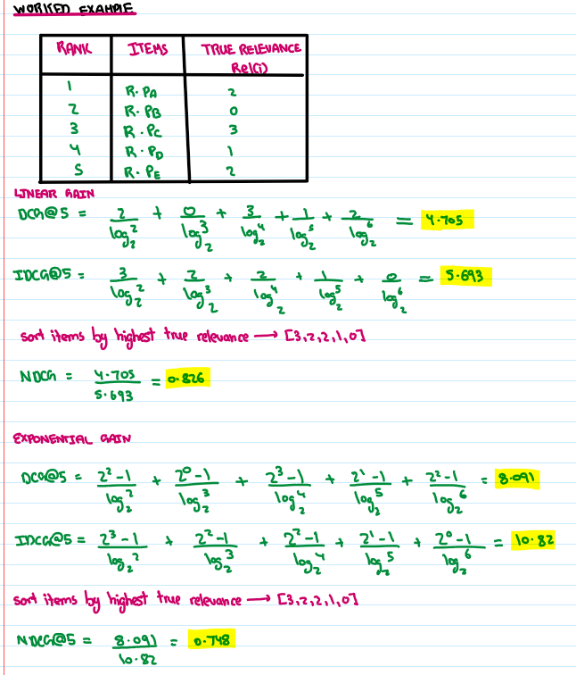

POST MID 2 CONTENT

Content-based Recommender Systems (CB-RS) - State of the Art and Trends
- Recommender systems: Guide users in a personalized way to interesting objects in a large space of possible options.
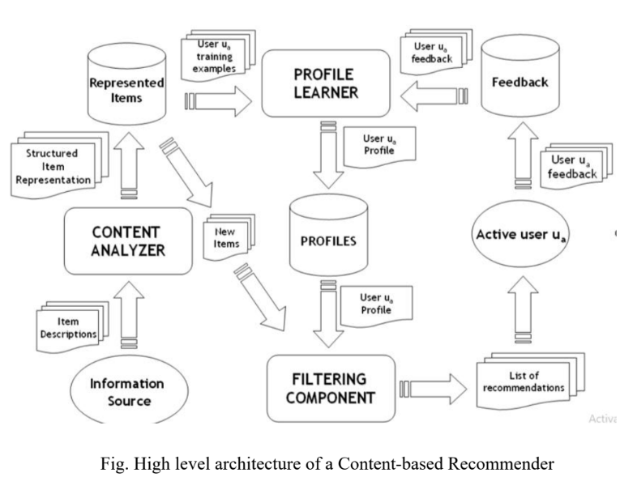
- Content-based recommendation systems: Try to recommend items similar to those a given user has liked in the past.

- Information Source provides Item Descriptions to the Content Analyzer
- Content Analyzer: Creates Structured Item Representation, populating Represented Items and New Items
- PROFILE LEARNER: Uses User training examples and Represented Items, and User feedback from the Feedback store, to produce and update the User Profile in PROFILES
- FILTERING COMPONENT: Utilizes the User Profile and New Items to generate the List of recommendations for the Active user
- Active user Ua: Provides User Ua feedback which is stored in Feedback

Item Representation

Structured Data
- Items: Represented by a set of features, also called attributes or properties
- Structured Data Definition: When an item is described by the same set of attributes with a known set of values
- Benefit: In this case, many ML algorithms can be used to learn a user profile

Textual Features and Ambiguity
- Item Descriptions: Often textual features extracted from Web pages, emails, news articles, or product descriptions
- Difference: Unlike structured data, textual features have no attributes with well-defined values
- Complication: Textual features introduce natural language ambiguity
- Problem: Traditional keyword-based profiles are unable to capture the semantics of user interests because they are primarily driven by a string matching operation

Semantic Analysis for Representation
- Semantic Analysis: An innovative approach to solve ambiguity and semantic problems by integrating it into personalization models
- Key Idea: Adoption of knowledge bases (e.g., lexicons or ontologies) for annotating items and representing profiles, to obtain a "semantic" interpretation of user information needs
- Semantic Lexicons (e.g., WordNet): Are structured dictionaries where words are grouped into synsets (synonym sets) and linked via semantic relations (hypernymy/hyponymy), helping with understanding term meaning (query expansion, word sense disambiguation)
- Ontologies: Formalize concepts, their properties, and interrelations, enabling reasoning about "is-a" hierarchies, associations, and domain-specific knowledge to provide deeper context

Keyword-based Vector Space Model (VSM)
- Models Used: Most CB-RS use simple models like keyword matching or the VSM with basic TF-IDF weighting
- VSM Definition: A spatial representation of text documents
- Document Representation: Each document is a vector in an n-dimensional space, where each dimension corresponds to a term from the overall vocabulary, with the vector elements being term weights indicating the degree of association between doc and term.
- Dictionary Derivation: The dictionary T is obtained by applying standard NLP operations (tokenization, stopwords removal, stemming)
- VSM Issues: Weighting the terms and measuring the feature vector similarity

TF-IDF Term Weighting
- Scheme: TF-IDF (Term Frequency-Inverse Document Frequency) is the most commonly used
- Core Idea: Terms that occur frequently in one document (TF), but rarely in the rest of the corpus (IDF), are more likely to be relevant
- Assumptions: rare terms are not less relevant (IDF assumption), multiple occurrences are not less relevant (TF assumption), and long documents are not preferred (normalization assumption).


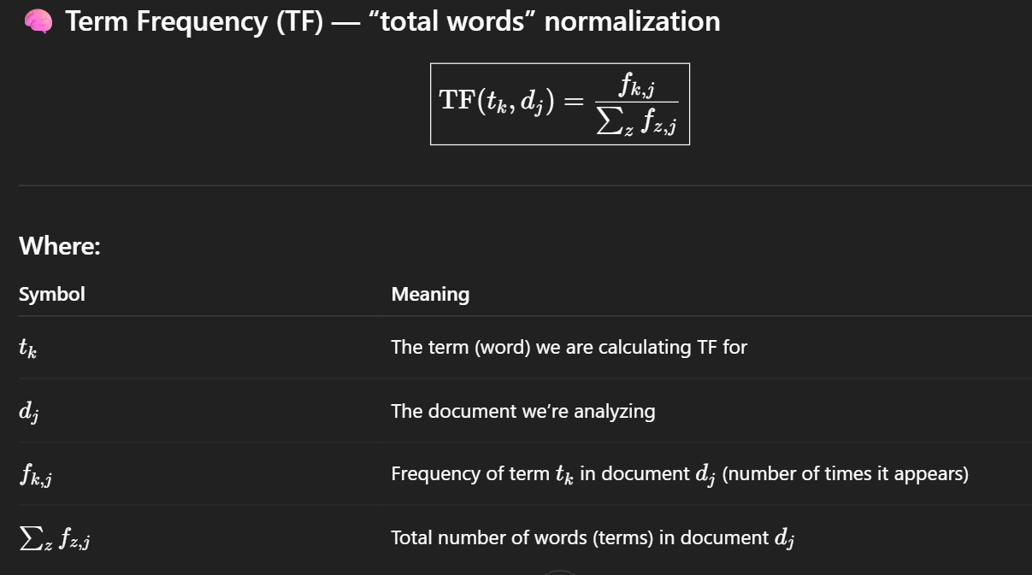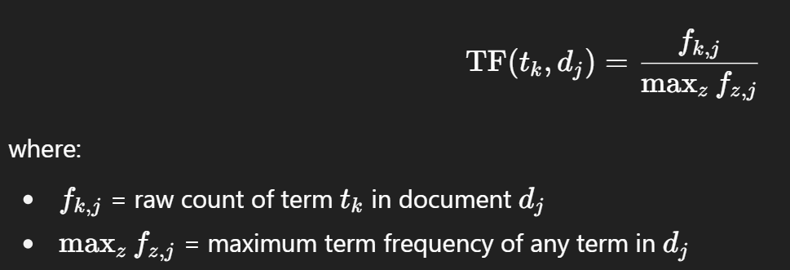
- Normalization: Term Frequency TF is normalized to fall in [0,1] interval; the resulting weight vectors are usually normalized by cosine normalization, which enforces the normalization assumption.
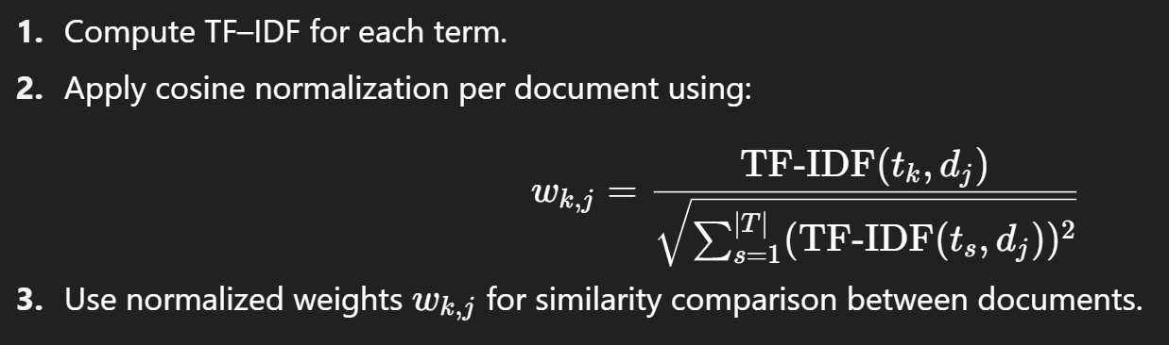

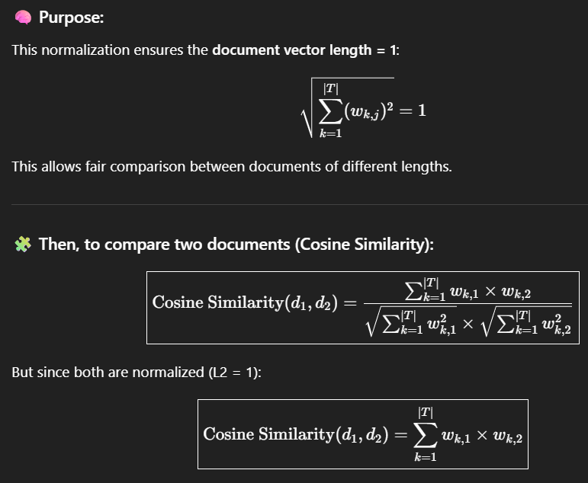

Cosine Similarity Measure
- Measure Required: A similarity measure to determine the closeness between two documents.
- Widely Used Measure: Cosine similarity.
- RS Application: Both user profiles and items are weighted term vectors, and predictions are derived by computing the cosine similarity between them.

Review of Keyword-based Systems
- Application Fields: Found in various fields: news, music, e-commerce, movies, etc.

Web Recommenders
- Letizia: A web-browser extension that tracks browsing behavior, builds a personalized model of keywords, and relies on implicit feedback (e.g., bookmarking) to infer preferences
- Personal WebWatcher: Learns interests from visited Web pages and documents one link away; processes visited pages as positive examples and non-visited as negative examples
- Amalthaea: Uses specific filtering agents specified by users with pages (weighted vectors) related to their interests

News Filtering Systems
- Profile Learning: Learning short-term and long-term profiles is typical
- NewT (News Tailor): Allows positive and negative feedback on articles/authors/sources; trains several filtering agents for different information types (e.g., political, sports)
- NewsDude: Learns a short-term user model based on TF-IDF (cosine similarity), and a long-term model based on a naïve Bayesian classifier

Semantic Analysis by using Ontologies (Advanced Systems)
- Benefit: Allows learning more accurate profiles containing references to concepts defined in external knowledge bases
- Motivation: Provides cultural and linguistic background knowledge for interpreting natural language documents and reasoning on their content
- Strategy Criteria: Evaluated by: type of knowledge source (lexicon, ontology), item annotation/representation techniques, type of content in user profile, and item-profile matching strategy
- Example Systems:
  - SiteIF: The first system to adopt a sense-based document representation for a multilingual newsWeb site
  - ITR (ITem Recommender): Provides recommendations in several domains (movies, music, books) using text document descriptions (plot summaries, reviews)
  - SEWeP (Semantic Enhancement for Web Personalization): Uses both usage logs and the semantics of a Web site’s content for personalization

Content-Based Recommendations: Preamble
- Basic Idea: Content-based recommendation systems match a user with items that are similar to those they have rated highly in the past.
- Similarity Basis: The similarity is determined based on item attributes (like genre, actors, keywords, etc.) rather than on rating correlations between different users.
- Suitability: This approach works well for personalized recommendations, where the focus is on tailoring results to individual user preferences.
- Examples: Common examples include movie recommendations (e.g., a user liking a particular director or actor) and websites or blogs (e.g., recommending news articles similar to one a user has read or queried).
- Content Definition: The term content refers to explicit attributes or characteristics of an item that describe it.
- Movie Example: For instance, a movie can be described by attributes such as Genre (Action / Superhero), Actor (Robert Downey Jr.), and Year (2019).
- Forms: Content can exist in textual form (titles, descriptions, tables of contents, etc.), where various techniques measure similarity or distance between textual documents.
- Feature Extraction: Features can be extracted either through NLP techniques (for text-based content) or from the signal itself (e.g., analyzing audio or image data).
- Formal Definition: Formally, a Content-Based Recommender System (CB-RS) matches users to items similar to those they have liked in the past, using the attributes of the items previously liked as the basis of similarity.

Vector Space Model
- Item Representation: Each item is represented as a vector of its attributes (features) in an n-dimensional feature space.
- Similarity Calculation: The angle between two item vectors is used to measure their similarity — smaller angles indicate higher similarity.
- User Representation: Each user is represented as a user profile vector, summarizing their preferences. Similarity between users and items is calculated in the same way (e.g., via cosine similarity).
- Illustration: Typically visualized in a 2D or 3D vector space, showing both user profile and item feature vectors.

Content-Based Filtering: Approach
- Common Use Case: This approach is often used for text-based product recommendations such as news articles or Wikipedia pages.
- Lazy Approach: It is called a lazy approach because it recommends items most similar to the content of a user’s previously liked or highly rated items without explicit model training.
- Novel Approaches: More advanced methods train classifiers (like decision trees or neural networks) to predict a user’s rating for an item based on its features.

Input Components
- A vector containing attributes for each unrated (unseen) item.
- A user profile vector summarizing the user’s tastes based on previously rated items.

Output Components
- A weighted matrix representing how much a user likes each attribute across all items.
- A recommendation vector containing predicted ratings for unseen items.

SEE SLIDES FOR WORKED EXAMPLES
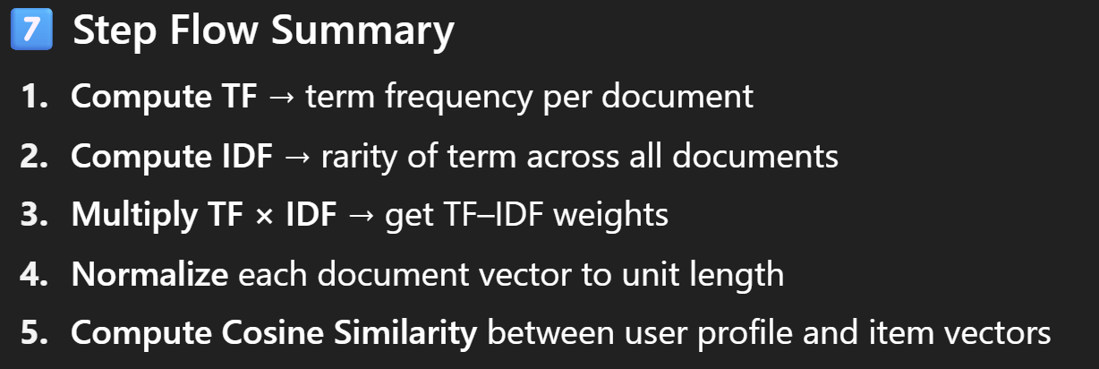
Content-based Filtering: Pros and Cons
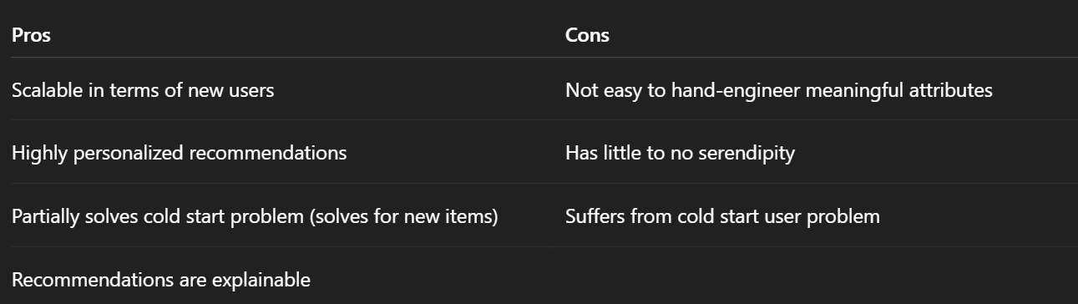

Collaborative Filtering (CF) and Neighbor-based CF (NBCF)

Terminologies
- System Setup: A list of m users and a list of n items.
- Opinion/Rating: Each user has a list of items with an associated opinion (rating).
  - Explicit Opinion: E.g., a 3-star rating for an app on Google Play Store.
  - Implicit Opinion: E.g., purchasing (or not) purchasing a certain product
- Active User: The user for whom the CF prediction task is performed.
- Metric: A metric for measuring similarity between users.
- Method: A method for selecting a subset consisting of closest neighbors
- Input (CF): A matrix of user-item ratings.
- Output (CF):
  - A (numerical) prediction indicating to what degree the active user will like or dislike an item
  - A list of top-N recommended items

Collaborative Filtering (CF)
- Basic Idea: Use "similarities" to recommend items to the active user
- Background: Used to be the most prominent approach for recommendations, well-understood, various algorithms/variations exist, applicable in various domains (movies, e-commerce, songs, ...)
- Approach Types (Model Based):
  - User-based CF: Find users most similar to me and recommend to me what they liked¹².
  - Item-based CF: Recommend to me an item that is similar to the ones I frequently like¹³.

User-based Collaborative Filtering (UBCF)
- Goal: To recommend items that neighbors have highly rated
- Steps:
  - Select the active user
  - Find similar users (neighbors) to the active user
  - Compute a prediction for an unrated item based on the neighbors' ratings
- Similarity Measures:
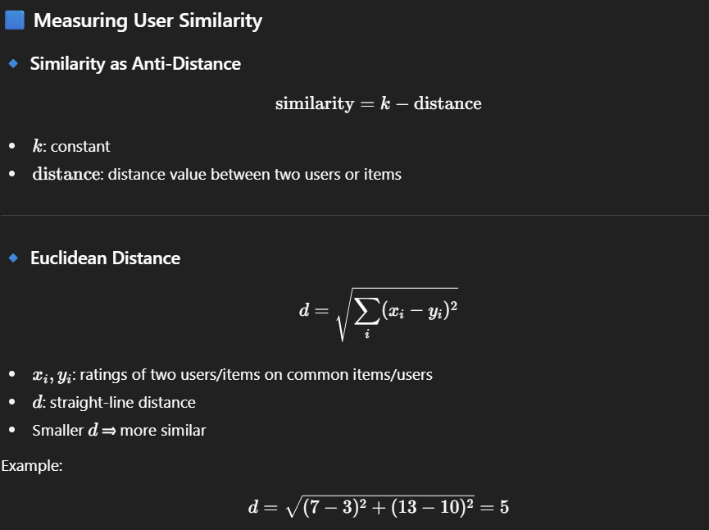



Now that we have found the users most similar to the active users, we can use them to predict our rating for active user.

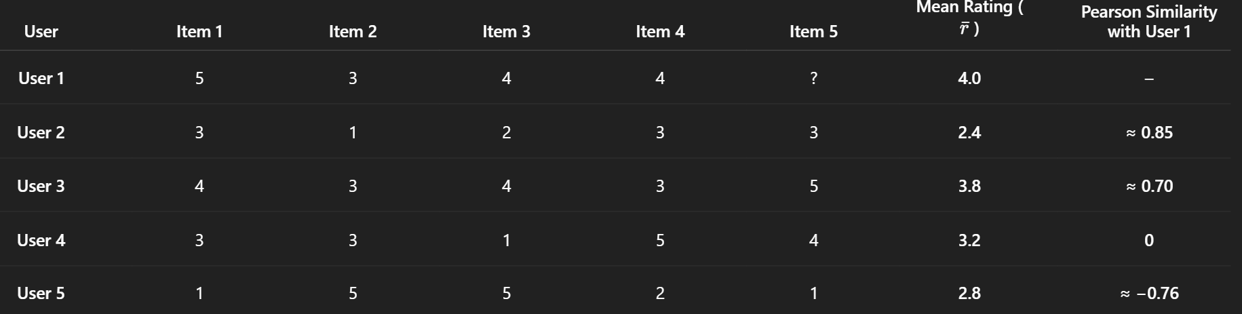
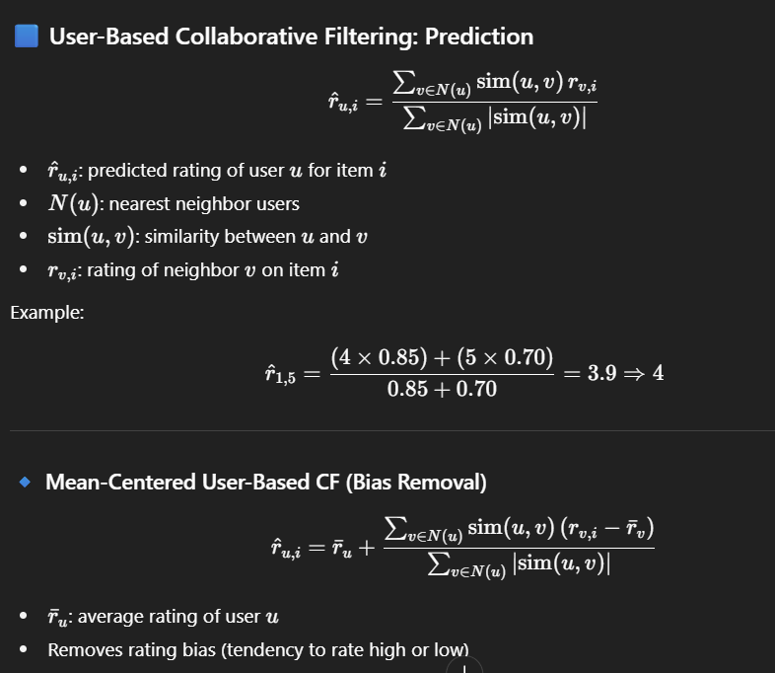


The prediction formula may give incorrect relative ratings due to user bias when using Pearson Correlation Coefficient, so a mean-centered prediction function is needed to remove this bias and make results consistent with Pearson correlation.

Pearson Correlation Coefficient: Issues
- Underlying assumption is that users dislike what they rated below average.
- This is not true in practice — we usually rate only what we liked or highly disliked.
- The correlation flattens in case of uniformly distributed ratings.
- Deviation from average rating on shared items will be zero in case of uniform rating.

Mean-centered prediction is used with Pearson correlation because Pearson already measures similarity based on users’ deviations from their mean ratings. So, the prediction formula must also be mean-centered to stay consistent with how Pearson computes similarity — both should account for users’ rating biases (i.e., how each user rates relative to their own average).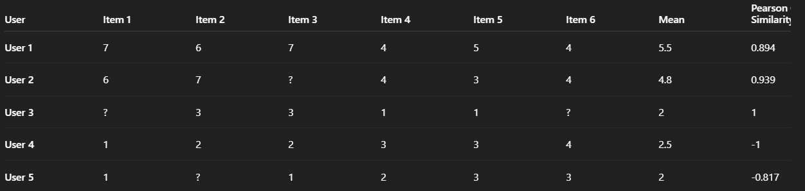
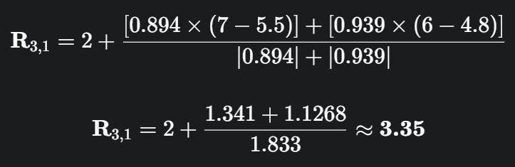
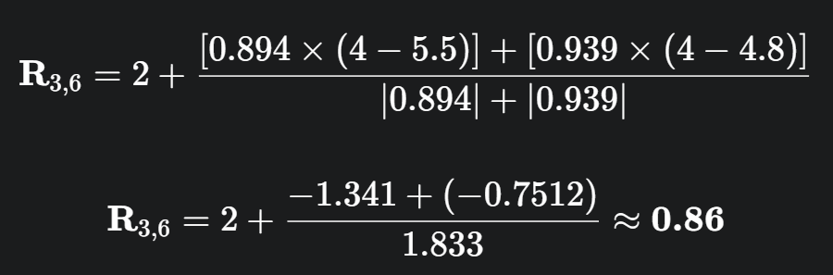

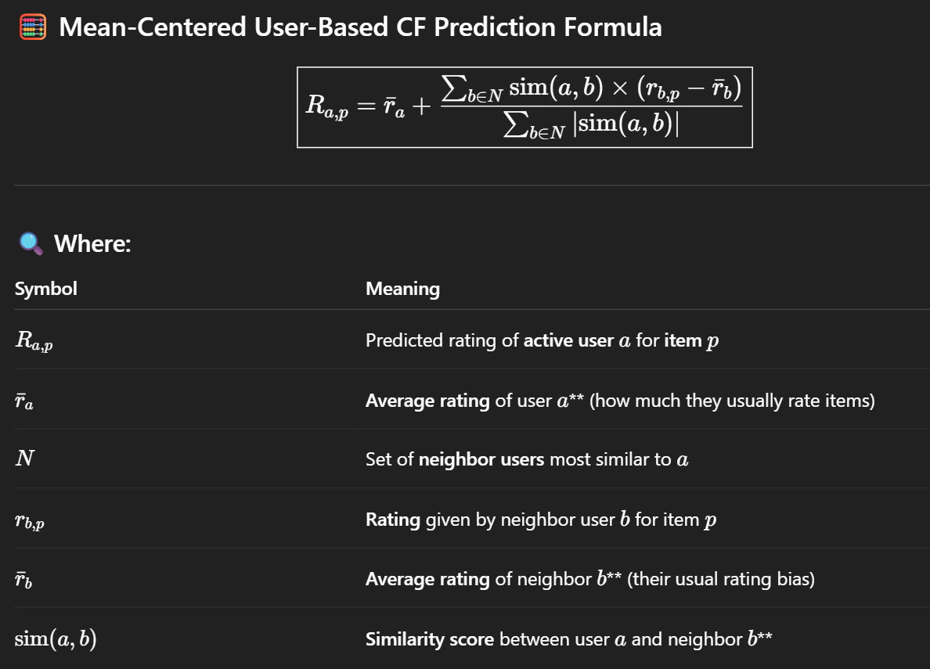

Item-based Collaborative Filtering (IBCF)
- Goal: To predict a rating by calculating the similarity between the item of interest and other items rated by the active user
- Steps:
  - Select the item to be rated
  - Find similar items (neighbors) to the item selected
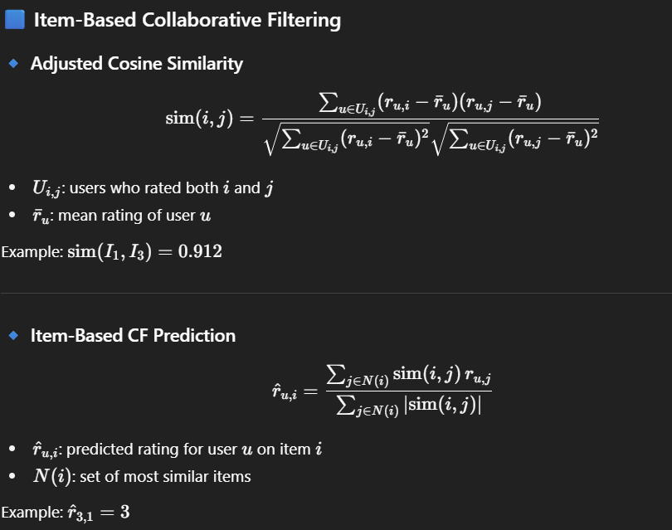
  - Compute a prediction for the unrated item based on the active user's ratings for the neighbors

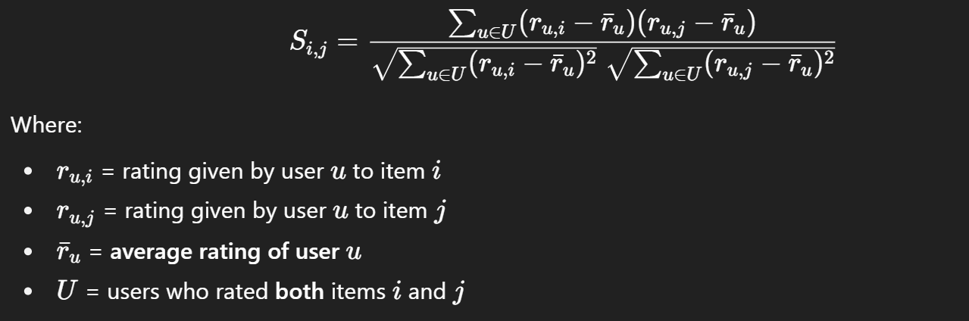

Collaborative Filtering vs. Classification

Unlike classification, there is no distinction between dependent and independent variables in collaborative filtering.

Collaborative Filtering is similar to missing value analysis but with a much larger matrix.

Improving CF: Significance Weighting

The reliability of any similarity function sim(u,v)\text{sim}(u, v)sim(u,v) between two users u and v is often affected by the number of common ratings between u and v

When the two users have only a small number of ratings in common, the similarity function sim(u,v) should include a discount factor to de-emphasize the importance of that particular user pair.

This method is referred to as Significance Weighting.

The discount factor kicks in when the number of common ratings between the two users is less than a particular threshold β\betaβ.

User-based Collaborative Filtering (CF)
Pros | Cons
Provides more diverse recommendations. | Generally not stable as user preferences change quickly.
Better choice if no. of users is much smaller than no. of items. | Cannot provide in-depth analysis on individual user.

Item-based Collaborative Filtering (CF)
Pros | Cons
Provides more accurate recommendations in general. | Prone to shilling attacks (a malicious user running a campaign to degrade some particular item).
Better choice unless the no. of items is much larger than the no. of users. | Provides much less diversity than user-based CF.
Is more stable. | —
Can provide better in-depth analysis on individual users. | —

Collaborative Filtering: Common Issues

1. Serendipity

Expand the user's taste into neighboring areas.

Basic Idea: At times, it’s good to recommend something different to the user.

2. Cold Start

Using CF without any initial data is very difficult.

Basic Idea: Ratings are not available for a newly launched website/store.

3. Long Tail

In practice, very few (relatively) popular items would be rated by users.

Basic Idea: A large number of items will be unrated and cannot be recommended easily.

Sparsity: Long Tail can lead to sparsity, i.e., not having enough data to make predictions.

4. Scaling

CF requires a lot of computational operations.

Basic Idea: For Amazon, the number of items and users can be in millions.

Possible Solution: Use offline training, i.e., don’t throw away pre-computed similarities.

Collaborative Filtering Based Recommender Systems (CF based RS)
- CF is the most popular implementation of a RS.
- These recommender systems are based on a rating matrix in which each user provides information about how much he or she likes or dislikes some items.
- CF methods act directly on the rating matrix to compute predictions and recommendations.
- CF can be subdivided into model-based and memory-based approaches.

1. Memory-Based Approaches
- In memory-based approaches, the information to recommend is obtained directly from the rating matrix.
- These algorithms mainly divide this approach into two kinds: user-based CF and item-based CF.

A. User-based CF
- The user-based CF analyzes a group of users that share similar interests or experiences with the target user and recommends the items that the group generally prefers.

B. Item-based CF
- The item-based CF recommends items that have a greater similarity with the list of items that a user liked in the past, so this approach uses similarities between the rating patterns of items to predict preferences.

2. Model-Based Approaches
- In model-based approaches, a model is created from the data, which subsequently is used to make recommendations.
- The most popular implementation of the model-based approach is Matrix Factorization (MF) and its variants NMF.
- In these methods, the ratings of users to items are modelled with a set of latent factors that represent features of the users and items.
- Nowadays, model-based methods are achieving better results in accuracy and performance.
- Main Problem (Interpretability): The main problem of matrix factorization is that the learnt latent space is not easy to interpret, so these models are not amenable to explaining their results.

3. Proposed Bayesian Probabilistic Approach
The proposed model aims to alleviate the interpretability problem of MF by applying a probabilistic approach for interpreting the factors of users and items.

Foundation (Naïve Bayes Classifier - NBC)
- The proposed approach has been designed based on the Naïve Bayes Classifier (NBC)
- NBC is a supervised multiclass classification algorithm based on applying Bayes’ theorem with the "naïve" assumption of conditional independence between every pair of variables.
- Variables in NBC:
  - Independent variables (X): the ratings of users to items.
  - Possible classes (C): each plausible rating value.
- NBC calculates a classification score P(C|X), that is proportional to the posterior probability, from the prior probability of each class P(C)$and the likelihood P(X|C) (eq1).
- The final classification is produced by the argument that maximizes the classification score (eq2).

Prediction Mechanism
- The proposed method will classify (predict) the new ratings of a user (i.e., the possible rating value that a user would give to an item) based on the existing ratings of the dataset.
- Prior Probabilities: would be computed based on the ratings of each user and item. (This concept is represented by equations (3) and (6)).
- Likelihood: Due to the independence assumption of NBC, the likelihood would be computed based on the ratings of a user or item regarding the ratings of another user or item respectively. (We use equations (4) and (7) to calculate the likelihood).
- Overall Goal: The proposed method computes the probability that a user rates an item with a specific rating value knowing the previous ratings that exist in the dataset. This probability is computed through the prior and likelihood according to equation (1).

Formulation Approaches
The approach defines three different methods based on how the prior and the likelihood are computed:
- User-based approach: prior and likelihood are computed according to the items that each user has rated.
- Item-based approach: prior and likelihood are computed according to the ratings that each item has received.
- Hybrid approach: it integrates user-based and item-based approaches to complement each other and improve the accuracy.
Reliability can be defined as the certainty the recommender system has in the computed predictions, or it represents the confidence of the model in a prediction.

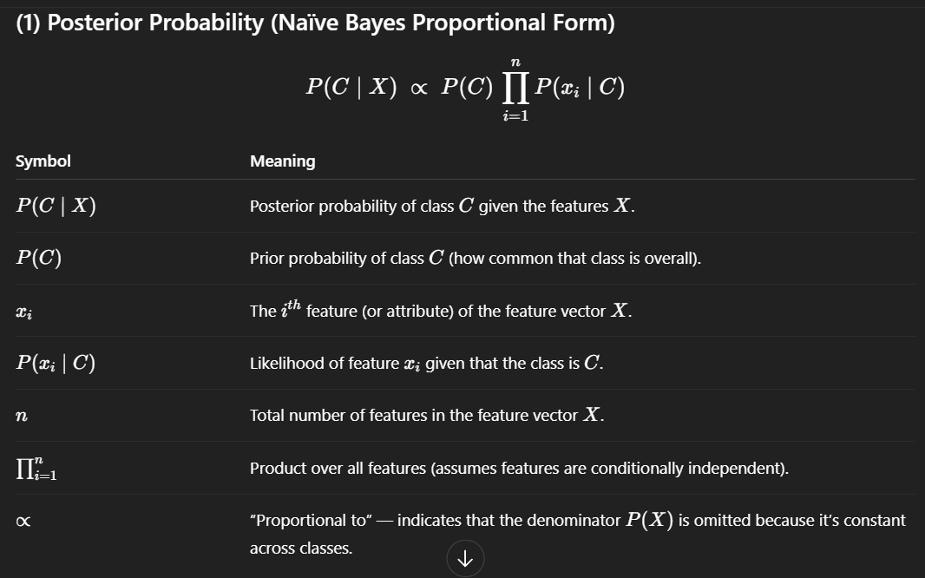
ALL EQUATIONS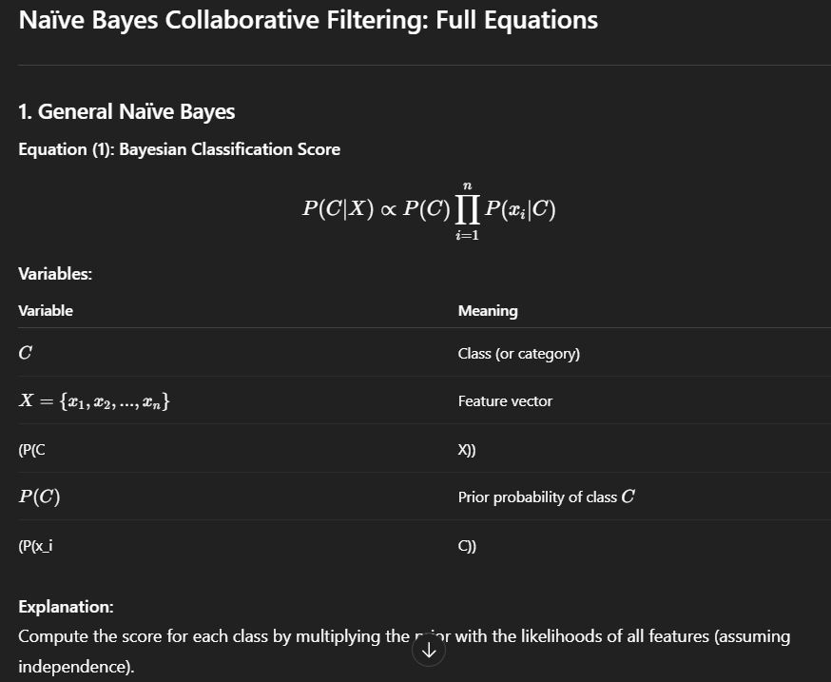

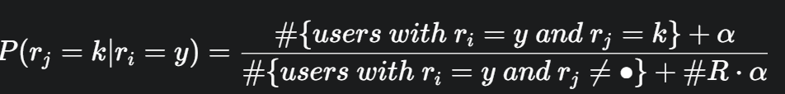
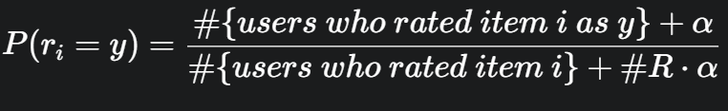
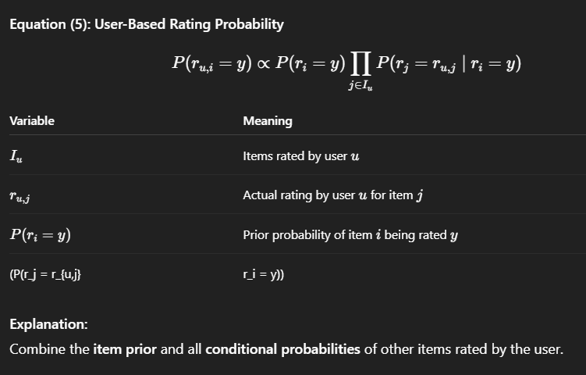
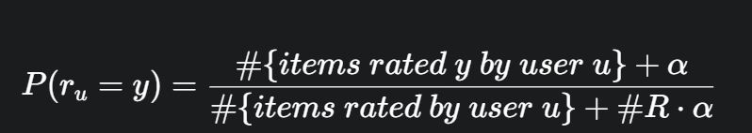
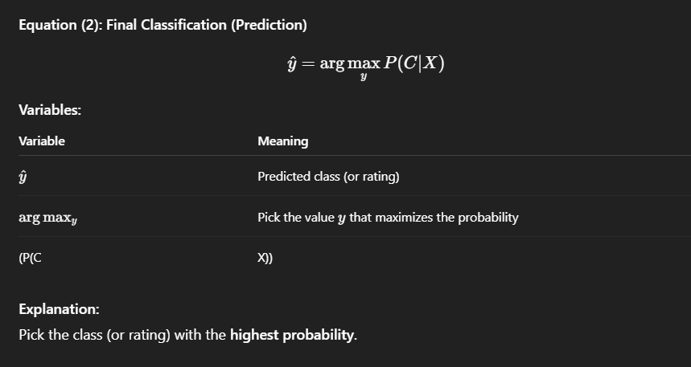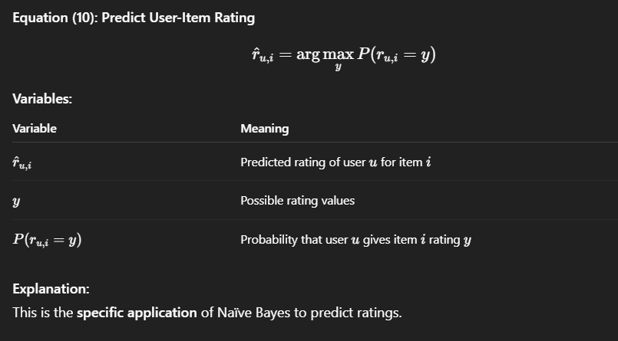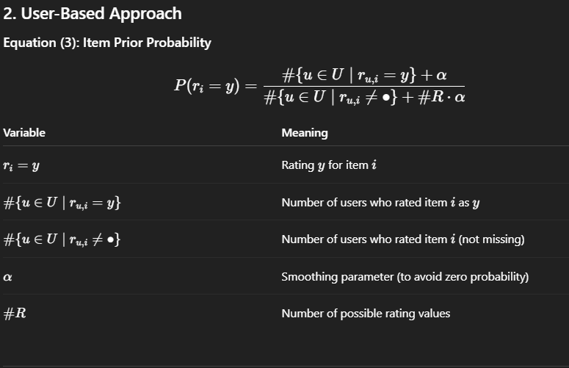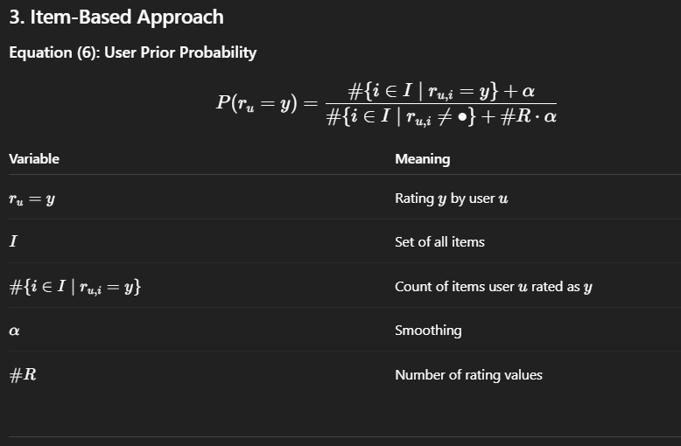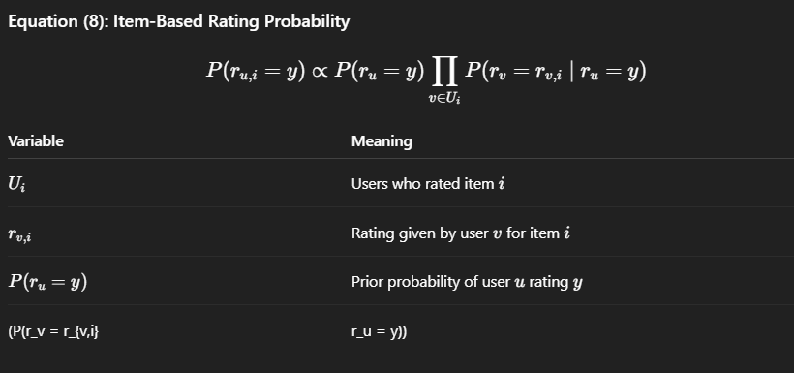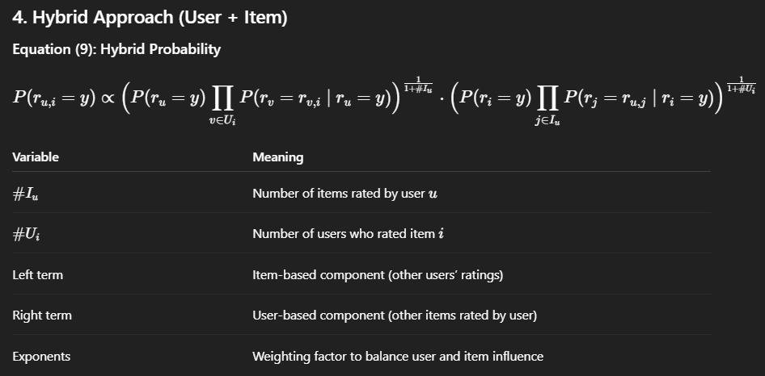

WORKED EXAMPLE UB & IB
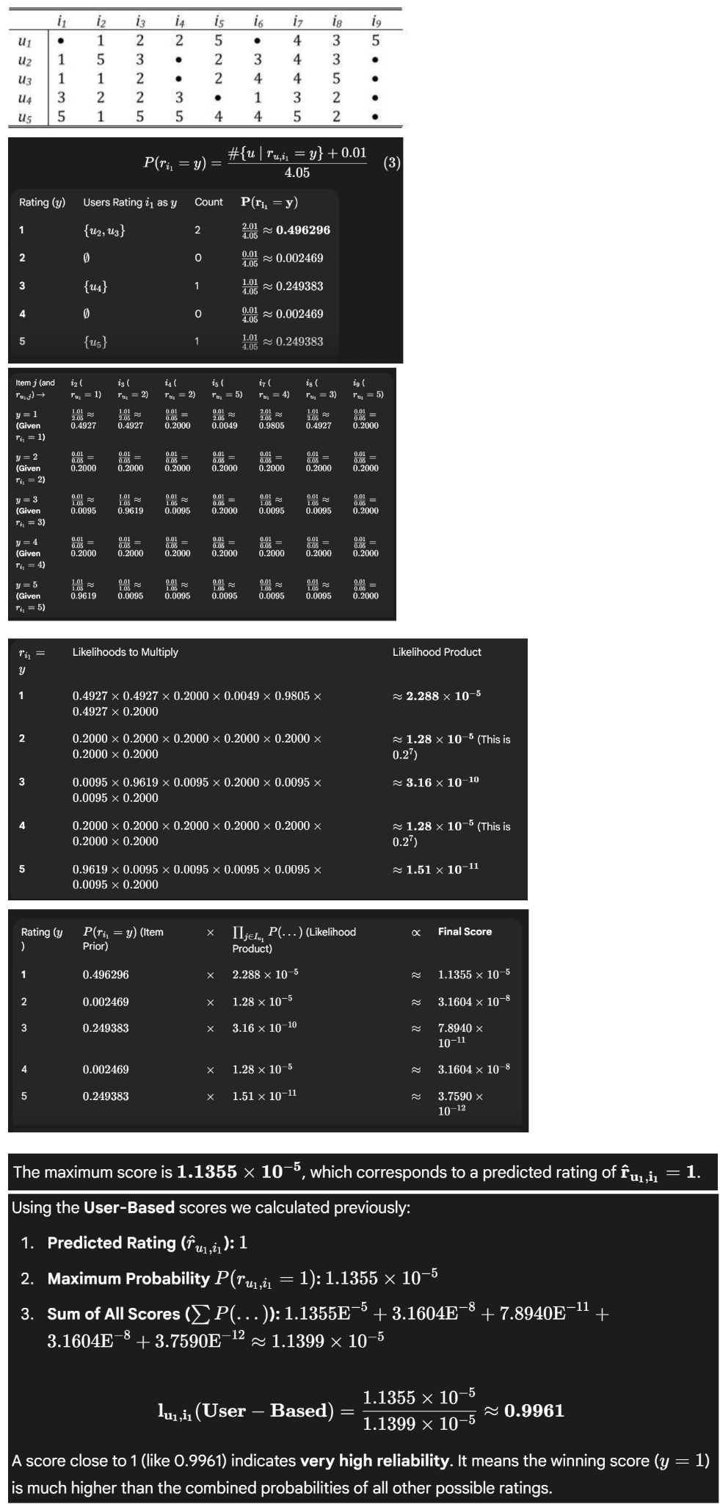
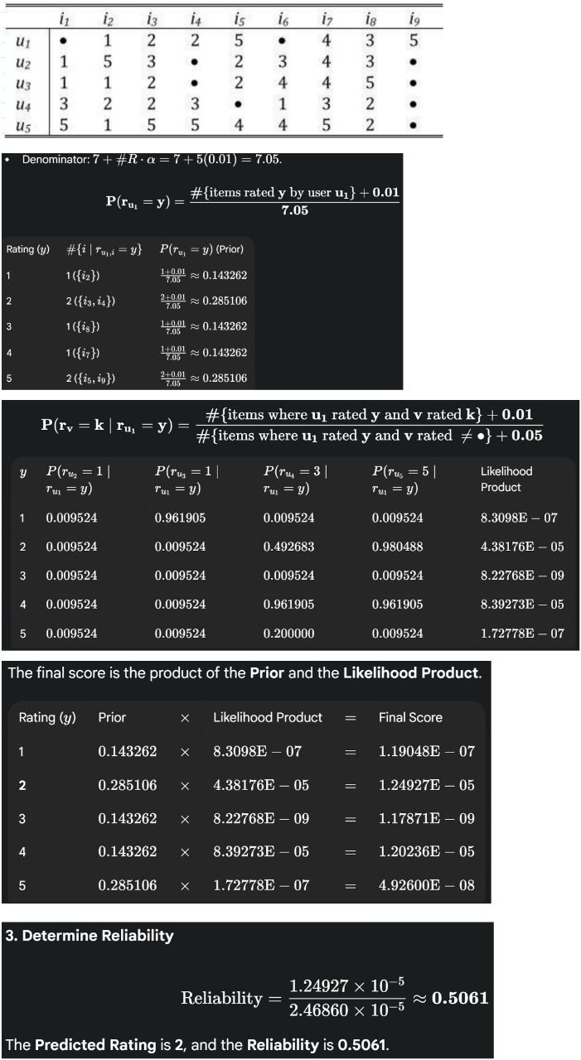
MATRIX FACTORIZATION

Factorization: A mathematical technique that allows a term to be decomposed into a product of two or more smaller terms.
Matrix Factorization: A technique in which user-item interaction matrix is decomposed into a product of two or three matrices.
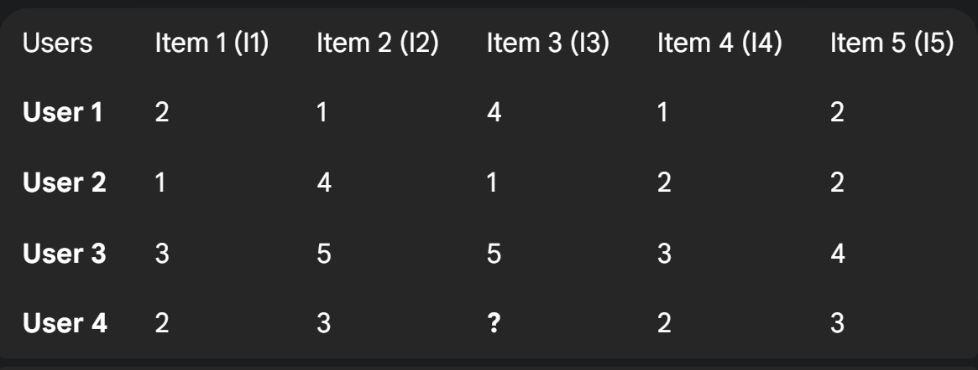
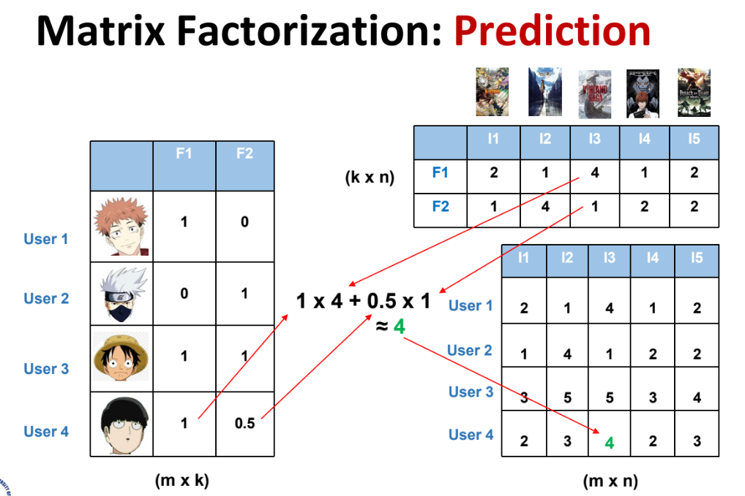

Pros | Cons
- It can take much less storage — for example, a 2000×1000 interaction matrix can be stored as two smaller matrices of 2000×100 and 100×1000 dimensions.  - Storage taken by a 2000×1000 matrix = 2M.  - Storage taken by separate matrices = 200k + 100k = 300k, which is much smaller.  - Predictions can be calculated quickly and easily. | - The cost of optimization during training is non-deterministic (it may vary and be computationally expensive).

KNOWLEDGE BASED

- History-based Techniques (like Collaborative Filtering and Content-based Filtering ) use historical data to make recommendations
- These techniques require data (a lot of it!), are not adaptable, and do not ask user for preferences
- Knowledge-based recommender systems exploit user requirements.

These systems are appropriate when:
- Customers want to explicitly specify their requirements.
- It is difficult to obtain ratings for a specific type of item.
- When ratings are time-sensitive.

Application domain:
- Expensive items, not frequently purchased, few ratings (car, house).
- Time span important (technological products).
- Explicit requirements of user (buying property).

Conceptual Goal of Knowledge-based Systems: "Give me recommendations based on my explicit specification of the kind of content (attributes) I want."
Input for Knowledge-based systems: User specification + item attributes + domain knowledge.

Approach | Conceptual Goal | Input
Collaborative | Give me recommendations based on a collaborative approach that leverages the ratings and actions of my peers/myself. | User ratings + community ratings
Content-based | Give me recommendations based on the content (attributes) I have favored in my past ratings and actions. | User ratings + item attributes
Knowledge-based | Give me recommendations based on my explicit specification of the kind of content (attributes) I want. | User specification + item attributes + domain knowledge

Knowledge-based System Types
- An example involves a user inputting constraints like price, number of rooms, total floor space for a house or car, and the website returns a list based on those constraints. This raises the issue: "Is this recommendation or simple query search?".
- Knowledge-based systems can be categorized into:
  - Constraint-based Systems: Based on explicitly defined conditions.
  - Rule-based Systems: Based on similarity to specified requirements.

Constraint-based Systems
- The user specifies their initial preferences:
  - All at once.
  - Incrementally using a wizard.
  - Interactive dialog.
- The user is presented with a set of matching items along with an explanation as to why a certain item was recommended.

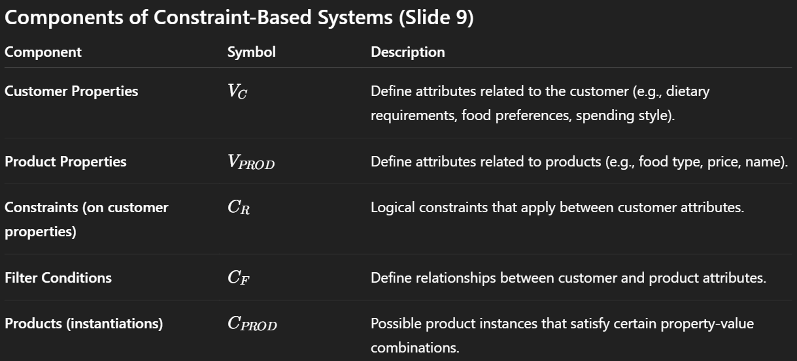

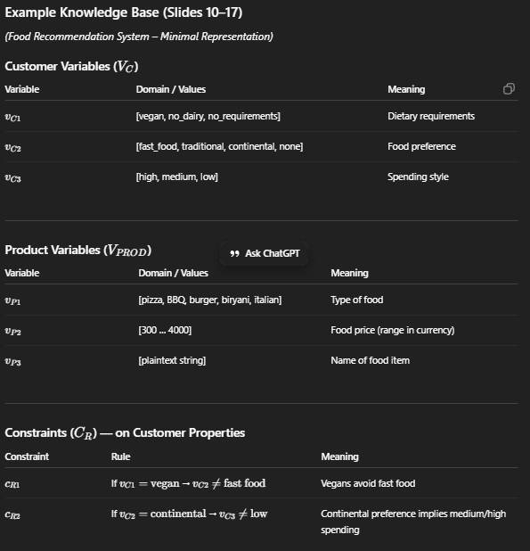
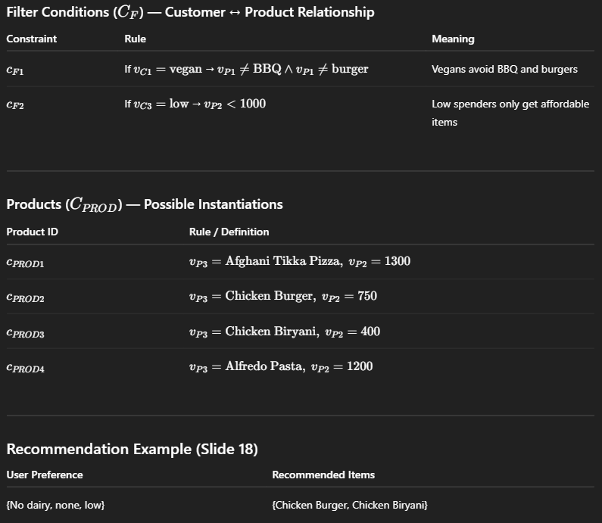

Constraint-based Implementation
- Constraint-based recommendations can be seen as a subset selection problem.
- Techniques used to find subsets:
  - QuickXPlain.
  - Linear Programming.
  - Gradient Descent (terrible idea!).

Issues and Solutions
- Issue: Users are presented with zero recommendations when no matching item is found.
  - Solution: Relax some constraints.
- Issue: Customers may be unsure about the values of their attributes.
  - Solution: Suggest reasonable default values for attributes.
- Issue: If business rules or items change often, knowledge-base has to be updated (which can be an expensive task!).

Case-based Systems
- In case-based systems, items are retrieved using similarity measures.
- The function sim(p, r) expresses for each item attribute value, its distance to the customer requirement
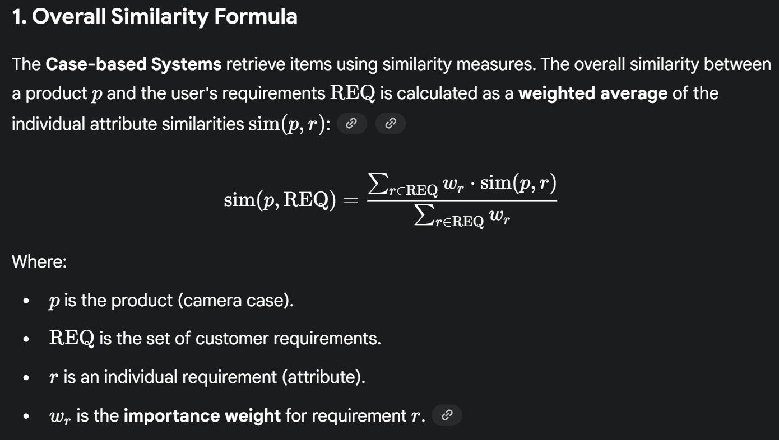

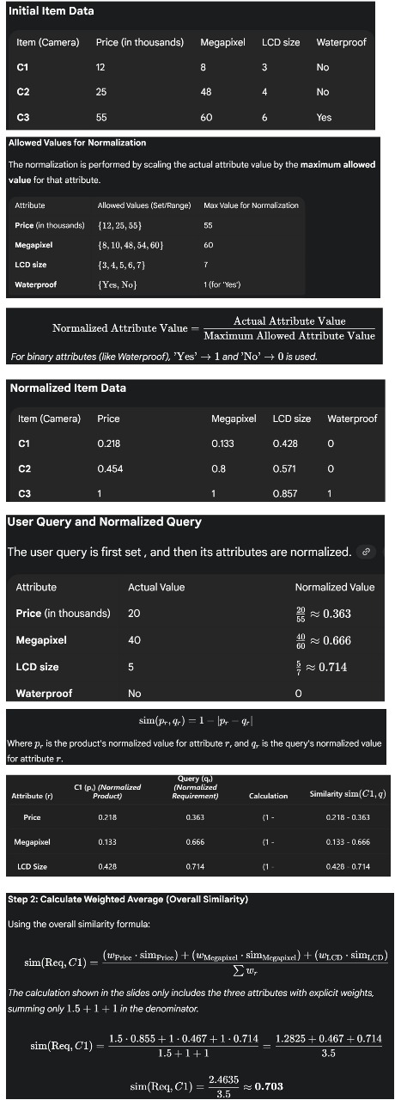

Knowledge-based Systems: Limitations
- Cost of knowledge acquisition and domain expertise
- Attributes (preferences) are not always independent

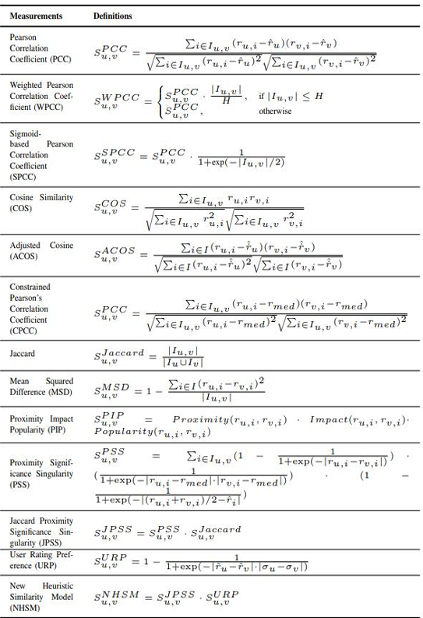

NEURAL NETWORKS

